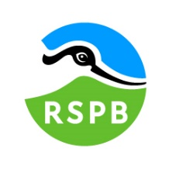
Date: 10th October 2023

Dear Sir or Madam,

TENDER FOR THE SUPPLY OF INNER FORTH BIKE BUS SERVICE OPERATION

Period:
- Phase 1: Service development: end of November 2023 to end of March 2024
- Phase 2: Service delivery: April 2024 to October 2025.

You are invited to tender in competition with others to provide the services specified above to the Royal Society for the Protection of Birds (“RSPB”).

The RSPB wishes to commission an operator with two minibuses to run a one day per week seasonal circular minibus with trailer service for walkers and cyclists in the Inner Forth area, between April and October in 2024 and 2025. This transport service aims to facilitate landscape exploration by visitors in the Inner Forth area. The proposed Inner Forth Bike Bus service sits within the Climate FORTH: ‘Furthering Our Resilience Through Heritage’ project as part of a wider suite of activities that will enhance the sustainable tourism infrastructure and provision within the Inner Forth area and support the local economy.

The successful candidate must hold a valid Public Service Vehicle (PSV) operators’ licence and demonstrate previous experience in delivering similar transport services. Thanks to Lottery players, these works are funded by the National Lottery through the Heritage Lottery Fund and by the Crown Estate via Fife Council. The Climate FORTH project has been devised by the Inner Forth Futures initiative for which RSPB acts as secretariat.

This is a two-phased contract. During the first phase, the operator will work with the Climate FORTH Team to refine and finalise the operational points of the Inner Forth Bike Bus Service. Upon completion of phase 1, the successful operator will be awarded phase 2 (service delivery), subject to agreement of the operational points.

The following documents are enclosed and must be, where applicable, completed and signed on behalf of the Operator.
Document A | Instruction and Information
Document B | The RSPB and Climate FORTH: A Brief Introduction
Document C | Specification of Services
Document D | Company Information
Document E | Form of Offer
Document F | Terms and Conditions
Document G | Certificate of Bona Fide Offer

Your tender response should be emailed to helene.corrieu@rspb.org.uk or uploaded to Public Contracts Scotland by 10am on Monday 13th November 2023.

Only tenders submitted in accordance with the RSPB’s Terms and Conditions will be considered. Any tenders that are incomplete, or received after the time indicated, may be disregarded.

If you wish to discuss any aspect of this tender prior to tendering, please email helene.corrieu@rspb.org.uk or call 07516 588 143.

If you do not wish to tender on this occasion, please let us know.

Yours faithfully

Helene Corrieu
Climate FORTH Project Officer – Visitor & Business Engagement
Inner Forth Futures
RSPB

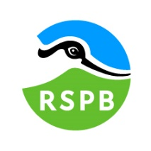 | Document A  Instructions and information

- This document is designed to be completed electronically. You are required to mark boxes, insert information or submit additional documentation in response to the questions herein. Whilst the text boxes should expand as you add text, if there is insufficient space for your response please attach a separate document clearly marked with the name of your Company, the reference number and the number(s) of the question(s) to which it relates. Please ‘sign’ this document by adding your name to the end of Document G.
- If you are unable to comply with a request for information or provide documentation requested then a written account explaining the absence of the information must accompany the return of this tender. Please be aware that the failure to respond to any of the questions, without a written reason, may result in a negative evaluation of that element within the overall evaluation of this questionnaire.
- The RSPB may require supplementary information or clarification or further evidence of the information given. The RSPB may wish to visit reference sites given as evidence of relevant experience.
- The RSPB may request interviews with all or a selection of applicants or none. Applicants will be notified in due course. The ability of operators may also be determined by, amongst other factors, references, certification, site visits and ‘mystery shopping’.
- Please answer the questions specifically for your company, NOT for the group if you are part of a group of companies. Please note the term “Company” refers to: Sole proprietor, partnership, incorporated company, co-operative, or voluntary organisation as appropriate.
- During the term of this agreement and for 1 year thereafter, neither party shall solicit to work for it any person who is or was employed by the other party and who has been involved in the provision of the Services at any time during the preceding 12 months. For the avoidance of doubt, if a person who is or was employed by the other party at the relevant time responds to a publicly advertised recruitment campaign, the recruiting party shall not be deemed to have solicited that person from the other party. If either party is in breach of this it shall pay to the other party an amount equivalent to the gross salary paid by that other party to the relevant employee for the final 12 months of employment.
- No charge will be made to the RSPB by applicants for any preparation costs accrued during the tender process, whether the applicant was successful or not.
- You are invited to submit your best offer for the work as detailed below. The RSPB reserves the right to undertake post-tender negotiations.
- If you require any further information or clarification regarding this tender please email helene.corrieu@rspb.org.uk or call 07516 588 143.
- It should be noted that in any contractual relationship that is subsequently entered into, reference will be made to the detailed information provided in the formal response to this tender document provided by the successful organisation. Thus answers and information given in your reply will become a binding part of the contractual obligations between yourselves and the RSPB.

- Timetable

Activity | Date/Deadline
Invitation to Tender issued | 10th October 2023
Tender documents to be returned | 10am on 13th November 2023
Tender evaluation and preferred provider identified  Any required additional certificates and declarations to be supplied by preferred provider. | w/c 13th November 2023
Award of contract | w/c 20th November 2023
Start-up meeting with Climate FORTH team | w/c 27th November 2023
Phase 1: Service development: Refinement and finalisation of the bus service’s operational points by the Operator and Climate FORTH Team. | End of November 2023 – End of March 2024
Phase 2: Service delivery: Start of the first season of the transport service | April 2024*
End of the first season of the transport service | End of October 2024*
Review of first season and variation of the service | Between October 2024 and March 2025
Start of the second season of the transport service | End of April 2025*
End of the second season of the transport service | End of October 2025*
End of contract | End October 2025*
* Exact dates to be agreed with the Operator.

- The RSPB does not bind itself to accept the lowest or any Tender, and reserves the right to accept part only of a Tender. The RSPB reserves the right to procure individual elements of the required solution from one or more operator as appropriate.
Whilst the RSPB aims to provide feedback on failed submissions this may not always be possible, and the RSPB is under no obligation to do so.

- Tender Evaluation Process

Essential requirements:
- Operator licencing: The Operator must hold a current valid Public Service Vehicle (PSV) operators’ licence.
- Vehicle capacity: Any vehicle used to deliver the service must have a minimum capacity of 8 passenger seats and a maximum capacity of 16 passenger seats.
- Vehicle’s engine type: Any vehicle used to deliver the service must meet at least Euro 5 emission standards, or be electric, hydrogen or hybrid vehicles.
- Vehicle’s towing capacity: Any vehicle used to deliver the service must be suitable to be fitted with a tow bar and tow the trailer provided (a trailer under 750kg Maximum Gross Weight). If not already fitted with a tow bar, the vehicle(s) must be suitable to be fitted with a tow bar.
Tenders that fail to meet all essential requirements may be excluded from consideration.

Tenders that fulfil essential requirements will be evaluated on the basis of the most economically advantageous tender, weightings as detailed below.

Criterion | Weighting
Service delivery (quality and conformity to specifications) | 50%
Price | 25%
Environmental considerations and accessibility | 15%
Relevant experience | 10%

- Tender submissions should include the following:
- Service delivery: including approach to vehicle checks, repair and maintenance, and emergency procedures, specifications of the proposed vehicles, details of where the trailers will be stored, any proposed revisions to indicative routes and timetables, proposed booking system, approach to quality management, provision of usage information. See document C Specifications, Scope of Services for full detail.
- Price: Breakdown of pricing schedule for phase 1 (service development) and phase 2 (service delivery), including overheads, insurances and management costs, exclusive of VAT.Pricing schedule to include tow bar installation and removal if required.
- Environmental considerations and accessibility: including accessibility compliance, plus any addition accessibility features, and environmental specifications of the proposed vehicles meeting at least Euro 5 emission standards or an electric, hydrogen or hybrid vehicle. Electric/Hydrogen/Hybrid/Euro 6 vehicles are preferred and will score higher in line with our sustainability criteria.
- Experience in delivering similar services.
- Certificates of Insurance: £10 million public liability cover is required for this contract. A minimum of £5 million may be considered if £10 million is not attainable. Applicable Motor vehicle insurance including hire and reward.
- Public Service Vehicle (PSV) operators’ licence number.
15. Contract management
An initial purchase order will be issued for the developmental stage (phase 1) of the contract. During phase 1 (service development), between November 2023 and March 2024 the operator will work with the Climate FORTH Visitor & Business Engagement Officer to refine and finalise the service, including:
- Identify specific stop locations within the general locations identified;
- Refine the service’s route and timetable;
- Set start and end dates for each season;
- Secure any required permissions from stop locations’ landowners/land managers;
- Identify how stop locations will be signposted;
- Select a suitable booking system;
- Agree a risk assessment.
By the end of this process, the operator will be awarded phase 2 of the contract (service delivery), subject to agreement of the operational points. A contract and Data Sharing Agreement will be agreed and signed by both the RSPB and the operator and a Purchase Order will be issued.
Phase 2 (service delivery) will start in April 2024 and will finish at the end of the second season of the Inner Forth Bike Bus, in October 2025, subject to the outcome of the review of the first season and variation of the service detailed in the timetable above.
The Operator will be expected to liaise with Helene Corrieu, Climate FORTH Project Officer, Visitor & Business Engagement throughout the duration of the contract. Unless otherwise agreed with IFF, the Operator must issue phase 1 invoice on completion of the service development phase. Phase 2 (service delivery) invoices must be issued monthly. The Operator will provide, with every phase 2 invoice, management information related to the services invoiced for. The detail of information required is listed in Document C Specifications, section 6.
The contract will be managed by Helene Corrieu, Climate FORTH Project Officer, Visitor & Business Engagement. All correspondence and queries relating to the delivery of the contracted work or requests for further information should be directed to helene.corrieu@rspb.org.uk.

Document B

A Brief Introduction

For details on the RSPB’s challenges and achievements in the previous financial year please go to
How the RSPB is Run | About Us - The RSPB
For an overview of the RSPB please go to:
About the RSPB - The RSPB

Inner Forth Futures
Who we are
Inner Forth Futures (IFF) is an initiative comprising 8 member organisations including the RSPB Scotland (lead agency), NatureScot, Clackmannanshire Council, Stirling Council, Falkirk Council, Fife Council, Green Action Trust, and Sustrans. Historic Environment Scotland are an advisory member to the initiative. As a grouping of local authorities, public bodies, charities and community groups, we are inclusive, cooperative and listening, but also decisive, and able to make things happen.
Where we work
The IFF project area (as shown in the map overleaf) includes the parts of Stirling, Falkirk, Clackmannanshire and Fife that surround the Inner Forth. This landscape defies the rules. Spectacular flocks of waders and wildfowl feed against a backdrop of steel towers and chimneys. Ancient castles gaze down on factories and warehouses, while the relics of past industries are now surrounded by woodlands and wildflowers. At the heart is the tidal River Forth and the dramatic mudflats and saltmarshes along its shores.
Sadly, many people only see the industry and commerce, while the area’s rich natural, cultural and historic heritage is often overlooked or neglected. We aim to create a greater appreciation and awareness of this rich heritage.
Our vision and objectives
Our vision is that the sense of connection, purpose and place that put the Inner Forth at the forefront of the industrial development of Scotland will be revitalised. We aim to achieve this using a landscape-scale approach with heritage at its core to engage people in new ways in its future management.
Climate FORTH: Furthering Our Resilience Through Heritage
The Climate FORTH project has been designed to contribute significantly to delivering our vision, it was developed in 2022 thanks to funding secured through the National Lottery Heritage Fund. Thanks to further funding success with National Lottery Heritage Fund and others, it will be delivered between 2023 and 2026. Climate FORTH will make the following differences for local heritage, people and place by working in targeted locations within the Inner Forth’s four local authority areas and 215 km2 landscape and disseminating our findings to inspire further action:
- The Inner Forth's heritage is valued and has inspired action to meet Scotland's net zero climate targets and made positive economic and societal change.
- The Inner Forth's natural and built heritage assets have an increased resilience to societal and climatic change.
- People and places within the Inner Forth have an increased resilience to change, as a result of heritage supporting the economy, healthy lifestyles, sustainable choices and a just transition.
Climate FORTH will support a move to a greener future and post-pandemic recovery and generate opportunities to share learning, influence adaption and inspire the change needed to transition to a climate resilient landscape in the Inner Forth and beyond. This will be achieved using locally-created, measurable resilience plans with participatory budgets for delivery, targeted action to demonstrate ways to increase resilience of heritage assets, tools and events to promote the principles of 20-minute neighbourhoods, skills development and capacity building, and initiatives to promote local, sustainable tourism. A new Youth Panel will engage a different demographic in decisions about their local places and Climate FORTH’s activities, including through a dedicated micro-grant scheme. See www.innerforthlandscape.co.uk for more information.
Map of the Climate FORTH project area:
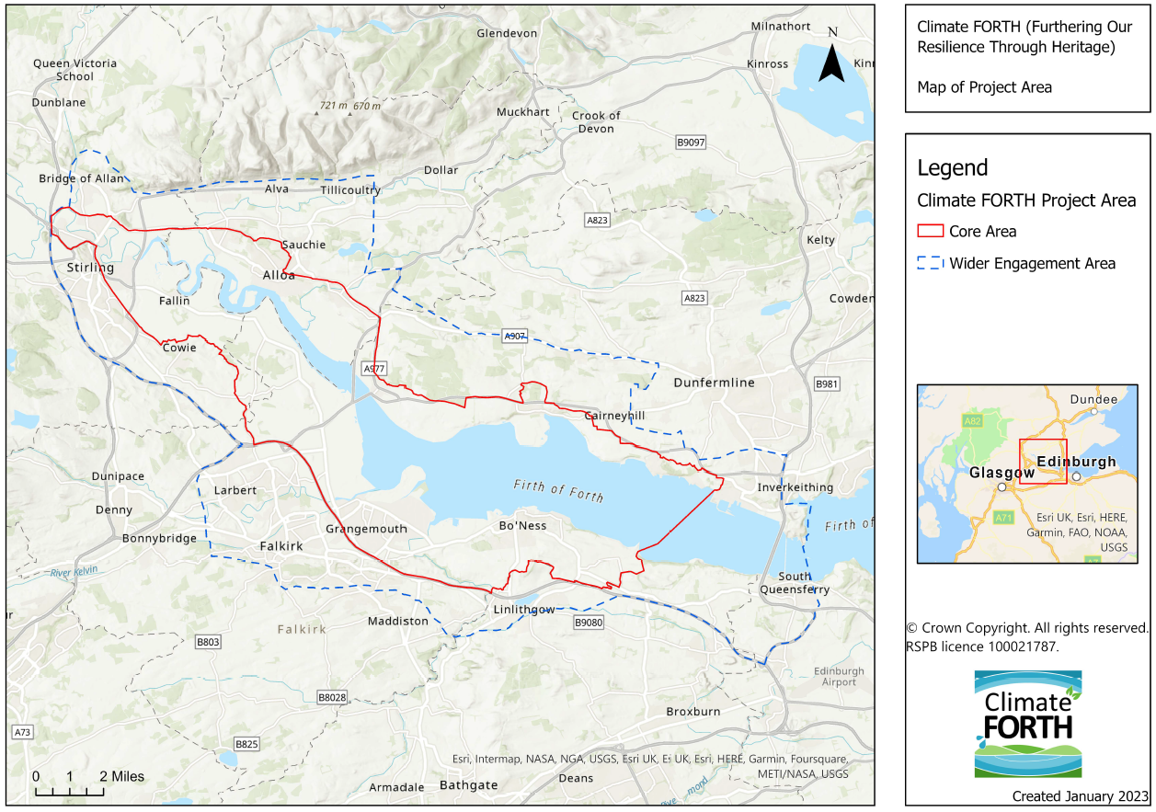

An explorable map of the Climate FORTH project area can also be seen at:
https://rspb.maps.arcgis.com/apps/webappviewer/index.html?id=1971361148964a3780ab5427a2fb8b07

Document C

Specification

What we want to achieve
The Inner Forth Bike Bus – a seasonal minibus service for walkers and cyclists
The RSPB, on behalf of Inner Forth Futures, wishes to commission an operator to run a one day per week seasonal circular minibus service for walkers and cyclists in the Inner Forth area. After an initial service development phase between November 2023 and March 2024, the Inner Forth Bike Bus service will be contracted to operate for two pilot seasons: from April to October 2024 and from April to October 2025.
The Service
This transport service aims to facilitate landscape exploration by visitors in the Inner Forth area. It will offer transport between various pre-advertised pickup and drop off points in the landscape, allowing visitors walking or cycling in the area to use the transport service to reach, or get back to, their starting point or a train station.
The Inner Forth Bike Bus information and timetable leaflet will be produced by IFF and provided to the Operator. A proof copy of the leaflet will be provided to the Operator before printing for checking. Promotion of the service will be carried out by IFF.
The operator must distribute Climate FORTH/ Inner Forth Bike Bus leaflets and feedback questionnaire to all passengers and collect any completed questionnaires.
Route & Timetable
The transport service will consist of two minibuses (supplied by the Operator) equipped with bike trailers operating on a circular route. The trailers will be lent by the RSPB to the Operator for the duration of the contract. The two vehicles will run simultaneously, in opposite directions (clockwise and anticlockwise) on a circular route between Alloa and the Forth Road Bridge, with stops that link and facilitate access to lesser-known heritage sites, walking and cycling routes, and link active travel hubs.
The transport service will run on a fixed timetable with the option to book in advance. The transport service will be available to users free of charge.
Trailers provided for bicycles
The two bike trailers provided (unbraked, under 750kg Maximum Gross Weight) will be designed to safely carry between 8 and 16 “standard” bicycles and electric bicycles and will be adjustable to safely carry 1-2 non-standard cycles, with the aim of encouraging inclusive cycling. In terms of non-standard cycle, the trailer design will allow the service operator to safely secure and carry a range of recumbent bicycles, tricycles, handcycles, and tandem bicycles, as well as child bike trailers. When adjusted to secure and carry non-standard cycles, the capacity to carry standard bicycles will be reduced. The operator will be required to safely load, secure and unload bikes into the trailer.
Specifications of the trailers provided by the RSPB:
- Two Vehicle Certification Authority (VCA) type approved Maximum Gross Weight (MGW) 750kg unbraked bike trailers (one for each vehicle) will be provided by the RSPB, along with the necessary bike securing equipment, and bike support conversion kits and tools (if required to secure different types of bikes) and lent to the Operator for the duration of the contract.
- The trailers provided will be designed to carry standard two-wheeler bicycles (e.g. road bikes, mountain bikes) and electric bikes using a standardised ready-to-use system. The equipment provided will enable the driver to load and safely secure the bikes onto the trailer.
- The trailers provided will also be designed to carry a range of shorter and longer frame bikes, tandem bikes, recumbent bikes, handcycles and trikes. The conversion kits provided (if required to safely secure these types of bikes) will enable the driver to make simple adaptations to the trailer to load and safely secure these types of bikes.
Scope of Service
The successful Operator will supply a service to which the following points will apply:
The information below is a statement of minimum requirements and is not intended to limit creative or original thinking in the preparation of proposals.
1. Inner Forth Bike Bus Service - Route and Timetable
1.1 Map of route
The route will have 11 stops, exact locations within each of these towns/villages to be refined and confirmed with the Operator during phase 1 (service development), between November 2023 and March 2024.
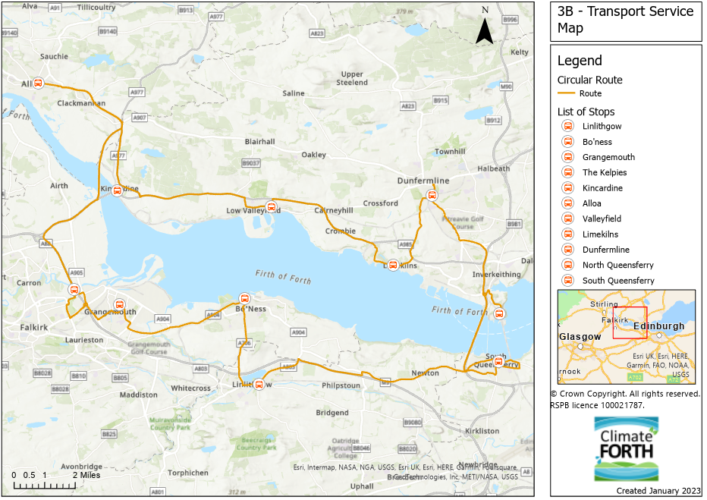
1.2 Indicative timetables (to be confirmed with Operator during phase 1): Every Sunday, from 1 April to 31 October 2024; every Sunday from 1 April 2025 to 31 October 2025.

The timetables below are indicative and are to be discussed and refined with the Operator during phase 1, between November 2023 and March 2024. The starting point (first and last stop of the day) can be any of the 11 listed locations as agreed between the RSPB and the Operator. The exact addresses of stops are to be discussed and refined with the Operator between November 2023 and March 2024.
Vehicle 1 – Clockwise service
Stop locations | Time | Time
Linlithgow | 08:30 | 13:45
Bo’ness | To include 10min per stop for passengers to board + load and unload bikes.  Arrival time at each stop and duration of the stop to be confirmed. | To include 10min per stop for passengers to board + load and unload bikes.  Arrival time at each stop and duration of the stop to be confirmed.
Grangemouth
The Kelpies
Alloa
Kincardine
Valleyfield
Limekilns
Dunfermline
North Queensferry
South Queensferry
Linlithgow | 12:50 – 45min break* | 18:05
Miles per journey | Approx. 67 miles (107 km) | Approx. 67 miles (107 km)
Miles per day | Approx. 134 miles (214 km)

Vehicle 2 – Anticlockwise service
Stop locations | Time | Time
Linlithgow | 09:30 | 14:45
South Queensferry | To include 10min per stop for passengers to board + load and unload bikes.  Arrival time at each stop and duration of the stop to be confirmed. | To include 10min per stop for passengers to board + load and unload bikes.  Arrival time at each stop and duration of the stop to be confirmed.
North Queensferry
Dunfermline
Limekilns
Valleyfield
Kincardine
Alloa
The Kelpies
Grangemouth
Bo’ness
Linlithgow | 13:50 - 45min break* | 19:05
Miles per journey | Approx. 67 miles (107 km) | Approx. 67 miles (107 km)
Miles per day | Approx. 134 miles (214 km)

* The time and location of driver’s breaks are to be confirmed by the Operator. In accordance with Regulation (EC) 561/2006, the timetable may need to be adjusted to add a second 45-minute break, depending on the additional driving time between the Operator’s minibus depot and the start location of the service.
1.4 Planned modification of service
Due to the pilot nature of this service, modifications or variations to the timetables, routes and stops may be required over the duration of the contract.
- Requests for temporary modifications will be notified in writing by the RSPB to the Operator 4 working days in advance. The Operator will be given 2 working days to respond. Any resulting changes in price as a result of increased mileage shall be agreed between the Operator and the RSPB.
- Requests for permanent modifications will be notified in writing by the RSPB to the Operator 10 working days in advance. The Operator will be given a period of 5 working days to review and comment on these changes. Any resulting changes in price as a result of increased mileage shall be agreed between the Operator and the RSPB.
- The Operator may submit requests for temporary modifications to the RSPB in writing 4 working days in advance. The RSPB will respond within 2 working days. Any resulting changes in price as a result of increased mileage shall be agreed between the Operator and the RSPB.
- The Operator may submit requests for permanent modifications to the RSPB in writing 10 working days in advance. The RSPB will review and comment on these changes within 5 working days. Any resulting changes in price as a result of increased mileage shall be agreed between the Operator and the RSPB.
- The Operator must not vary the contracted services without written consent from the RSPB.
- Due to the pilot nature of this service, any changes in route, frequency, stop locations and timetables for the 2025 season will be implemented before the start of the second season (April 2025 to October 2025). These changes will be based on service users’, drivers’ and Operator’s feedback and service usage analysis, and will be agreed upon between the RSPB and the Operator prior to implementation.
- The timetables and routes are subject to variation in case of road or bridge closure or diversion.
1.5 Unplanned Modification of service
- The Operator must inform the RSPB of any breakdown or other emergency or unforeseen circumstance which has affected the route or timing of the contracted services by the next working day. This may include but is not limited to staff or passenger illness, severe weather or severe weather warning, emergency road closures.
- The Operator must inform RSPB of any accident or injury to any person within one working day.

Are you able to meet this specification (1.1 - 1.5) in full? If so, please give details below.
If not, please state any differences in service offered.
Please detail your proposed timetable for the service, to include:
- Start and end (day and month) of season 2024 and season 2025.
- Proposed start location of the service, along the circular route shown on the map.
- Distance/drive time between the Operator’s minibus depot and the proposed start location
- Any proposed revision to the timetables for minibus 1 (clockwise) and 2 (anticlockwise), including revisions of the route, day of operation (Sunday preferred, but Saturday may be accepted as an alternative), stop locations and duration, timings and length of driver’s breaks. Please note that the final timetables will be agreed with the successful contractor.

Specification met? Yes /Part met / No (tick as appropriate)
Details

2. Vehicle specifications
2.1 Any vehicle(s) used to deliver the service must:
  - Comply with statutory provisions and regulations governing Public Service Vehicles and their operations.
  - Have a minimum capacity of 8 passenger seats and a maximum capacity of 16 passenger seats.
  - Be suitable to be fitted with a tow bar and tow the trailer provided (a trailer under 750kg Maximum Gross Weight). If not already fitted with a tow bar, the cost associated with the installation and removal (if appropriate) of a tow bar on the vehicles that will be used to deliver the service should be included in the detailed pricing schedule.
  - Be in a clean and presentable condition both internally and externally when in service.
  - Display the Inner Forth Bike Bus signage provided by the RSPB when the service is in operation. Sign size, material and display location to be agreed with the successful operator.
  - Comply in all respects with the provisions of all legislation relating to licensing, operation, insurance, construction, use, fitness, equipment and safety, and any other compliance issue relating to vehicles.
- Any vehicle used to deliver the service must contain a first-aid kit which can be made available to passengers for their use.
  - The type(s) of vehicle(s) used to deliver the service must only be as specified by the tenderer in their tender submission, except with the written approval of the RSPB, or in case of breakdown or emergency (only for the duration of the emergency). The list of vehicles, including substitute vehicles, used or intended to be used, must be kept up to date and provided to the RSPB, and must include vehicle type, registration number and seating capacity.
2.2 Environmental concerns and sustainability
- Any vehicle used to deliver this service must meet at least Euro 5 emission standards or be an electric, hydrogen or hybrid vehicle. Electric/Hydrogen/Hybrid/Euro 6 vehicles are preferred and will score higher in line with our sustainability criteria.
- Tyres influence fuel consumption. Low rolling resistance tyres (LRRT) will score higher against our sustainability criteria.
- Motor lubricants impact fuel consumption and may contain hazardous substances: please state what lubricant will be used for the vehicles used.
- Eco-driving reduces carbon emissions: please state whether the proposed drivers have completed, or will complete, any Eco-driving training.
2.3 Accessibility
- Any vehicle used to deliver the service must comply with any accessibility, disability and discrimination laws and regulations applicable to the service provided and vehicle type and category. Any accessibility feature beyond the minimum legal requirements will score higher in line with our accessibility criteria.
Are you able to meet this specification in full? If so, please give details below.
If not, please state any differences in service offered.
Please provide full details of the vehicles to be used to provide the service, including the age of the vehicle, service history, engine details, telemetry data on actual emission and fuel consumption or any other fuel consumption information available, type of tyres, motor lubricant used, any eco-driving training completed by the proposed drivers, and any accessibility features, as well as a list of substitute vehicles. This should also include any details of relevant certifications.
Please also detail what vehicle checks are undertaken before the start of each timetabled service, during the service, as well as any maintenance schedule.

Specification met? Yes /Part met / No (tick as appropriate)
Details

3. Trailer Responsibilities
3.1 Trailer: Operator’s responsibility
- To safely store the two trailers provided by the RSPB for the duration of the contract.
- To only use the trailers provided by the RSPB to operate the Inner Forth Bike Bus over the timescales agreed in 2024 and 2025.
- To insure the trailers and equipment provided for the full replacement value whilst they are in your custody, care and control.
- To attach and operate the trailers properly and in the manner that they are designed to be used.
- To ensure that the trailers and equipment are kept in safe working order, by carrying out regular maintenance checks and routine maintenance work, and recording these checks. A trailer maintenance schedule will be provided: this will include pre-use checks before each use, and other regular checks to ensure the trailer remains roadworthy. The trailer(s) and all lights must be visually inspected at the start of each journey, to ensure it is fit for purpose and remains roadworthy.
- The Operator will notify the RSPB if repair work on the trailer(s) is required over and above that covered by routine maintenance. Repairs to the equipment over and above those covered by routine maintenance will be discussed and agreed with the RSPB.
- To ensure that each trailer is displaying the same number plate as the vehicle it is being towed by whilst in operation.
- Liability for bikes carried on the trailer: The driver or Operator must inform passengers with bicycles or tricycles that their cycles are carried at their own risk. The information must be made available at the time of booking as well as before boarding for passengers without bookings.
3.2 Trailer: Driver’s responsibility
- The driver(s) will be responsible for loading, securing and unloading passenger’s bikes into the trailer using the adjustable straps and equipment provided.
- Initial training on bicycle loading, unloading and securing onto the trailer may be provided for drivers at the start of the contract by the RSPB. The Operator will be available and will make drivers available for training as part of the contract.
Are you able to meet this specification in full? If so, please give details below.
If not, please state any differences in service offered.

Please also provide details of the insurance under which the trailers and associated bike securing equipment and tools will be covered and the location at which the trailers will be kept when not in use over the duration of the contract.

Specification met? Yes /Part met / No (tick as appropriate)
Details

- Operator’s licencing, registration and other responsibilities
- The Operator is required to have a current relevant Public Service Vehicle (PSV) Operator's Licence for the duration of the contract and must produce the licence on demand for inspection by the RSPB. The Operator must immediately notify the RSPB of any change to their PSV operators’ licence at any point during the contract time period.
  - The Operator, the services provided, the vehicles and drivers must comply in all respects with the provisions of all legislation relating to licensing, operation, insurance, construction, use, fitness, equipment and safety, and any other compliance issue relating to vehicles.
- The Operator must ensure that each driver has a current valid Passenger Carrying Vehicle (PCV) driver’s licence and Certificate of Professional Competence (CPC) (Driver’s Qualification Card) relevant to the type of vehicle to be driven.
- The Operator must ensure that the driver(s) are trained and competent in the use of the trailers, and in how to safely load, secure and unload bikes on the trailer.
- The Operator must ensure that the driver(s) are equipped with a charged mobile phone to be able to report and respond to any breakdowns or emergencies.
- The abovementioned points also apply to any sub-contractors appointed by the successful operator to deliver the service at any time. It is the responsibility of the Operator to ensure that equivalent checks have been made on any sub-contractors delivering the service.
- The Operator must record and report any Health & Safety related accidents or incidents.
- Please note that the Inner Forth Bike Bus service will be free of charge for passengers and will not be registered as a Local Bus Service with the Traffic Commissioner. The Operator will therefore not be able to claim a Network Support Grant.
Are you able to meet this specification in full? If so, please give details below.
If not, please state any differences in service offered.

Please also provide your current valid PSV operators’ licence number, and list the checks that will be undertaken on drivers to ensure their suitability to drive the vehicles used to deliver the service safely and responsibly.

Specification met? Yes /Part met / No (tick as appropriate)
Details

- Booking System & Customer Care
- The Operator must make advance bookings possible for both passenger seats and bike space. Advance bookings will be recommended to service users but not compulsory, and the service can therefore also be used by passengers without prior booking.
- Priority will be given to passengers with seat/bike space reservation and passengers without prior bookings will only be able to board if enough space is available between their boarding and disembarking locations.
- The drivers must distribute Inner Forth Bike Bus feedback questionnaires to all passengers on boarding and collect any completed questionnaires on disembarkation.
- The drivers must be welcoming and demonstrate high levels of customer care.
- Ideally drivers will have good knowledge of local area attractions.
- Ideally the Operator will be able to support promotion of the service, but this is not essential.
- A data sharing agreement will be established between the Operator and the RSPB prior to the start of the contract to allow the Operator to take advance bookings and supply selected personal data to RSPB.
Are you able to meet this specification in full? If so, please give details below.
If not, please state any differences in Service offered.

Please describe the booking system that will be used, including when bookings can be made for a specific service, and how spaces/seats will be booked by service users, how cancellations can be made and how the information will be provided to the drivers.

Specification met? Yes /Part met / No (tick as appropriate)
Details

- Provision of service usage information
- Every week the driver(s) will log the number of passengers and cycles boarding and alighting and arrival/departure times, on a log sheet supplied by IFF. A copy of the completed log sheets will be emailed to IFF each week.
- Every month during phase 2 (service delivery), the Operator will invoice RSPB for services provided. With every monthly invoice, the Operator will provide management information related to the services invoiced for. This information will include:
  - Number of breakdowns, if any.
  - Number of journeys not fully completed, including the date and which section of the route was not served.
  - Any customer feedback or complaints received by the operator or driver.
  - Any health and safety accidents or incidents incurred by the driver or customers whilst the service is in operation.
- Along with this information, with every monthly invoice, the Operator will return to IFF the questionnaires filled in by the passengers.
Are you able to meet this specification in full? If so, please give details below.
If not, please state any differences in service offered.

Specification met? Yes /Part met / No (tick as appropriate)
Details

- Access to vehicles and information
- The Operator must allow the RSPB at any time to inspect all relevant licences and documentation of drivers and vehicles used to deliver the contracted services, including any sub-contractor’s drivers and vehicles.
- The Operator must allow the RSPB at any time, with or without prior notice, to inspect the vehicles and trailers used to deliver the services, including any sub-contractor’s drivers and vehicles.
- If requested, the Operator must provide details of working hours of all drivers delivering the contracted services, including any sub-contractor’s drivers.
Are you able to meet this specification in full? If so, please give details below.
If not, please state any differences in service offered.

Specification met? Yes /Part met / No (tick as appropriate)
Details

- Service Performance Review, Contract Failure or Contract Termination
- Either party can request a meeting to discuss service performance and contract issues at any point, where concerns or issues related to the following have occurred:
  - Punctuality & reliability (timetable, vehicle and advance booking capability)
  - Vehicle specification (not meeting requirements set out in the original Invitation to Tender)
  - Customer satisfaction and/or complaints
  - Cost (where changes in service cost due to service changes or other unforeseen circumstances make the service no longer viable).
- The RSPB may issue a written notice to the Operator terminating this contract if, following a service performance review meeting, the service provided continues to fail to meet the requirements set in the original Invitation to Tender and agreed to in the signed contract.
- The operator must keep records until the end of the Climate FORTH project (October 2026) or longer where relevant legislation or licensing requires.
- On completion of Phase 1 (service development), the Operator will be awarded phase 2 (Service delivery) of the contract, subject to agreement of the operational points.
- Previous experience
If not already detailed in your responses to sections 1 - 8, please use this section to provide detail of previous experience providing similar services, including experience providing timetabled services, public transport services, services with vehicles of similar type and size, and services with a trailer.

Details

- Pricing schedule
Please provide a breakdown of all costs to deliver the proposed service, for both phase 1 and phase 2, including overheads, insurances and management costs plus any other costs, exclusive of VAT. Please state whether or not you are VAT registered. Pricing schedule to include tow bar installation and removal if required.

Details

Document D

Company Information

1.0 | General
1.1 | Registered Name  Trading Name (if different)
1.2 | Correspondence Details  Name of person applying on behalf of the company  Address:  Telephone:  Mobile:  Email:
 | Registered office Address (if different from above)
1.3 | Company Registration No (if applicable)  VAT registration number (if applicable)
1.4 | Date company was founded (if a limited company, date of incorporation)
1.5 | Company structure and nature of company  Please outline the nature of the company, whether it is a partnership, sole trader, plc etc.  Is the company proposed as party to the contract part of a larger organisation? If so, please explain the relationship between the various parts of the organisation, up to the ultimate holding company.  Current number of full time equivalent staff currently employed by the company (not larger parent company)
1.6 | Accreditation by / Membership of Trade Association(s)  Is your Company registered with any industry accreditation body? YES NO  If yes, please provide details:  Is your Company on any public sector Framework agreements? YES NO  If yes, please provide details:  Please state membership of any professional bodies/ other associations below:
1.7 | Quality Assurance  Is all / part of your company ISO9001 Quality Assured? YES NO  Is all / part of your company ISO14001 Quality Assured? YES NO  If yes please provide copy of certification  Do you have any other Quality Assurance? If Yes, please summarise details below
1.8 | Environmental Commitments  Is all / part of your company registered under or signed up to Science Based Targets (https://sciencebasedtargets.org/net-zero), SME Climate Hub Climate Hub (https://smeclimatehub.org/uk/), ISO 14064, ISO 14067 or a similar scheme to calculate and reduce your impact on the climate? YES NO  If Yes, please summarise details below
2.0 |  | Financial & Business Probity
2.1 |  | Judgements etc.  Are there any judgements, claims or suits pending or outstanding against your company?  Yes No If Yes, please provide full details  Has your company ever failed to complete a contract?  Yes No If Yes, please provide full details
2.2 |  | Please answer all of the following questions as they apply to your Company’s circumstances. Please confirm that:  1) being a company, no resolution has been passed or Order of the Court made for the company’s winding up otherwise than for the purposes of bona fide reconstruction or amalgamation, nor has a receiver, manager or administrator on behalf of a creditor been appointed in respect of the company’s business or any part thereof, nor is it the subject of any proceedings for any of the above procedures, nor is it the subject of similar procedures under the law of any other state.  Confirmed Not confirmed Non-applicable  2) being a partnership, it has not granted a trust deed or become otherwise apparently insolvent, or it is not the subject of a petition presented for sequestration of its estate.  Confirmed Not confirmed Non-applicable  3) being an individual, you are not bankrupt, or have not had a receiving order or administration order made against you, or have not made a composition or arrangement or trust deed with or for the benefit of your creditors, or have not made any conveyance or assignment for the benefit of your creditors, or have not had a petition presented for sequestration of your estate or do not appear to be able to pay or to have no reasonable prospect of being able to pay a debt within the meaning of the Insolvency Act or any similar procedure under the law of any EC member state.  Confirmed Not confirmed Non-applicable  4) no Directors, Partners, Associates or the Company Secretary have been involved in any Company which has been liquidated or gone into receivership.  Confirmed Not confirmed Non-applicable  5) none of the Directors, Partners, Associates or the Company Secretary have been convicted of a criminal offence relating to the conduct of their business or profession.  Confirmed Not confirmed Non-applicable  6) neither the Company nor any of the Directors, Partners, Associates or Company Secretary has committed an act of grave misconduct in the course of their business or profession.  Confirmed Not confirmed Non-applicable  7) all obligations relating to the payment of taxes under the law of any part of the United Kingdom or the EC member state in which the Company is established has been fulfilled  Confirmed Not confirmed Non-applicable  8) all obligations relating to the payment of social security contributions under the law of any part of the United Kingdom or the EC member state in which the Company is established have been fulfilled.  Confirmed Not confirmed Non-applicable  If you have ticked ‘Not confirmed’ for any questions above please give details here
2.3 | Please list the names of any Director, Partner, Associate or Company Secretary who have been employed by the RSPB, giving department and dates.  Please give details of any Director, Partner, Associate or Company Secretary who have a relative who is employed by the RSPB at a senior level.  Please list the names of any Director, Partner, Associate or Company Secretary who have any involvement in other Companies who provide services to the RSPB  Is any work being undertaken or likely to be undertaken during the next three years by the Company or staff within it which could give rise to a conflict of interest through acting for third parties or otherwise? If yes, please explain the actual or likely circumstances and how such potential conflicts of interest would be handled.

 | 2.4 |  | Insurances (a scanned copy of each certificate may be requested)
 |  |  |  |  | Insurer | Policy No | Value of Cover | Expiry Date
 |  |  | Employers Liability
 |  |  | Public Liability
 |  |  | Prof. Indemnity
All Risks
(if applicable)
 | 2.5 |  |  | Has your company (or any building/project you have undertaken) won any awards, accolades or recognition?  YES NO If yes please provide full details.
3.0 |  | Health & Safety and Environment
3.1 |  | Has your company been served with any enforcement or prohibition notices or been prosecuted in the past 5 years for breaches of health & safety legislation?  YES NO If yes please provide full details.
3.2 |  | Has your company been served with any enforcement or prohibition notices or been prosecuted in the past 5 years for breaches of environmental legislation?  YES NO If yes please provide full details.
3.3 |  | Has your company been served with any enforcement or prohibition notices or been prosecuted in the past 5 years for breaches of data protection legislation?  YES NO If yes please provide full details.
3.4 |  | Have any restrictive clauses in relation to your company’s Employer’s Liability, Public Liability or Professional Indemnity Insurance policies been enforced in the last 5 years due to past Health & Safety performance?  YES NO If yes please provide full details.

Document E

Form of Offer

Cost
Cost for providing goods/services, as outlined in specifications (Document C) | £ + VAT

Added Value
As well as any charity rate that you may be able to offer, the RSPB is always open to corporate partnerships that deliver benefit to your organisation, the RSPB and nature. Working as part of your CSR agenda we can provide opportunities for fundraising, secondments, interns and volunteering, offering your staff both personal and career development opportunities. We also welcome all forms of gifts in kind as valuable contributions to our work.

Operators should provide details of any associated added value features/services/gifts in kind available to the RSPB under the terms of this Tender. (Attach separate document if needed).

Please note, added value donations will not be part of the criteria we use to decide on which operator to choose.

References
Operators are requested to provide details of three references from their existing clientele, supplying full name, address, telephone number, email address, contact name, period of Contract and the estimated annual value of the Contract. In supplying this information, Operators shall have granted the RSPB permission to seek such information as deemed necessary, in relation to the Operator’s performance with their nominated references.
Reference 1
Company Name
Address
Telephone No |  | Ext
Email
Contact |  | Dates of work
Nature of work done |  | Value of contract

Reference 2
Company Name
Address
Telephone No |  | Ext
Email
Contact |  | Dates of work
Nature of work done |  | Value of contract

Reference 3
Company Name
Address
Telephone No |  | Ext
Email
Contact |  | Dates of Work
Nature of work done |  | Value of contract

Document F

RSPB Terms and Conditions

The basis of the contractual agreement between RSPB and the applicant is detailed in the RSPB Terms and Conditions of Purchase of Goods and Services (the “Terms and Conditions”). In applying for this tender you are explicitly agreeing to be bound by these Terms and Conditions for the duration of the contract plus any special terms and conditions to be agreed in writing between the RSPB and the Operator prior to finalising the Service, including additional provisions in compliance with applicable laws and regulations and RSPB internal policies and procedures. If you have any queries on these Terms and Conditions please state these below. (Attach separate document if needed)

The RSPB expects that all operators it works with to adhere to certain ethical and environmental standards. Please download the RSPB Ethical and Environmental Procurement Policy and tick this box if you agree to be bound by its terms and conditions

Document G

Certificate of Bona Fide Offer

We certify that this offer is made in good faith, and that we have not fixed or adjusted the amount of the offer by or under or in accordance with any agreement of arrangement with any other person. We also certify that we have not, and we undertake that we will not:

1 a) communicate to any person other than the person inviting these offers the amount or approximate amount of the offer or proposed offer, except where the disclosure, in confidence, of the approximate amount of the offer is necessary to obtain insurance quotations required for the preparation of the offer;

b) enter into any agreement with any other person (i) to refrain from making an offer, or (ii) as to the amount of any offer to be submitted;

2 pay, give or offer or agree to pay or to give any sum of money or other valuable consideration directly or indirectly to any person for doing, or having done, or causing, or having caused, to be done any act or thing of the sort described in 1a) or 1b) above in relation to any offer or proposed offer for the goods/services.

We acknowledge that if we acted or shall act in contravention of this certificate, the RSPB will be entitled to cancel the agreement and to recover from ourselves the amount of any loss and expense resulting from such cancellation.

I state that everything in this tender submission is truthful, that if found to be untruthful the RSPB can terminate any agreement between the RSPB and the Operator formed on the basis of this tender, and we will pay to the RSPB any loss or expenses the RSPB suffers as a result of such untruthfulness, whether an agreement is entered into or not.

In this certificate, the word “person” includes any persons and any body or association, corporate or unincorporated; “any agreement or arrangement” includes any transaction, formal or informal, and whether legally binding or not.

Signed
On behalf of
Date

Please note: a name added in an electronic document is functionally equivalent to a signature.

