Date: 25 May 2022

Dear Consultant or Agency,

Request for Quotation: Climate FORTH Community Heritage Group Training and Mentoring Programme

You are invited to quote in competition with others to provide the services specified below.

RSPB Scotland, on behalf of the Inner Forth Futures partnership (IFF), wishes to commission a consultant or agency to design a Community Heritage Group Training & Mentoring Programme for the Climate FORTH project. The programme will sit as part of a wider suite of activities that aims to enable communities around the Inner Forth to make more of heritage assets and increase the climate resilience of both heritage and communities. The programme is aimed at people or groups who own and/or manage assets or want to manage an asset but who do not have skills or confidence yet. This piece of work will identify training and mentoring opportunities to give individuals and groups the skills, confidence and capacity to make the most of heritage assets. It will also develop a training and mentoring plan to increase community awareness and skills and aid them in identifying and addressing maintenance issues related to heritage.

This contract will involve working closely with the Climate FORTH Project Officer for Community and Youth Development and other members of the Climate FORTH team and IFF partnership as needed, building on their understanding of the project and its activities. It is critical that the programme developed is realistic in its scope and resource requirements and is owned by the Climate FORTH team and wider IFF partnership. The successful candidate should demonstrate previous experience in similar work. The Community Heritage Group Training & Mentoring Programme plan will be submitted as part of a Stage 2 bid to the National Lottery Heritage Fund.

We anticipate this work is largely desk-based. However, the consultant may benefit from visiting and engaging with representatives of heritage themed community groups within the Climate FORTH project area to sense-check the training and mentoring proposals. Meetings can be held face to face or over Zoom/ Microsoft Teams, by agreement.

The value of the work will be up to £5,000 excluding VAT. The works will occur in July and August 2022.

Your quote should be emailed to Connie Dawson, Climate FORTH Project Officer – Community and Youth Development connie.dawson@rspb.org.uk by 17:00, Monday 20 June 2022.

If you wish to discuss any aspect of this quote prior to submitting, please email connie.dawson@rspb.org.uk

Yours faithfully,

Connie Dawson
Climate FORTH Project Officer – Community and Youth Development. Inner Forth Futures partnership. RSPB

A Brief Introduction

For details on the RSPB’s challenges and achievements in the previous financial year please go to
https://ww2.rspb.org.uk/about-the-rspb/about-us/how-we-are-run/annualreview/

For details on the RSPB Mission please go to
https://ww2.rspb.org.uk/about-the-rspb/about-us/our-mission/

Inner Forth Futures

Who we are
Inner Forth Futures (IFF) is an initiative of 9 organisations comprising 8 members - RSPB Scotland (lead agency), NatureScot, Clackmannanshire Council, Stirling Council, Falkirk Council, Fife Council, Green Action Trust, and Sustrans and 1 advisory body, Historic Environment Scotland. As a grouping of local authorities, public bodies, charities and community groups, we are inclusive, cooperative and listening, but also decisive, and able to make things happen.

Where we work
The IFF project area (as shown in the map overleaf) includes the parts of Stirling, Falkirk, Clackmannanshire and Fife that surround the Inner Forth. This landscape defies the rules. Spectacular flocks of waders and wildfowl feed against a backdrop of steel towers and chimneys. Ancient castles gaze down on factories and warehouses, while the relics of past industries are now surrounded by woodlands and wildflowers. At the heart is the tidal River Forth and the dramatic mudflats and saltmarshes along its shores.
Sadly, many people only see the industry and commerce, while the area’s rich natural, cultural and historic heritage is often overlooked or neglected. We aim to create a greater appreciation and awareness of this rich heritage.

Our vision and objectives
Our vision is that the sense of connection, purpose and place that put the Inner Forth at the forefront of the industrial development of Scotland will be revitalised. We aim to achieve this using a landscape-scale approach with heritage at its core to engage people in new ways in its future management.

Climate FORTH: Furthering Our Resilience Through Heritage

The Climate FORTH project has been designed by the IFF partnership to contribute significantly to delivering our vision and is being developed in 2022 thanks to funding secured through the National Lottery Heritage Fund. It will be delivered between 2023 and 2026, subject to a further successful funding bid.

Climate FORTH will make the following differences for local heritage, people and place by working in targeted locations within the Inner Forth’s four local authority areas and 215 km² landscape and disseminating our findings to inspire further action:

- The Inner Forth's heritage is valued and has inspired action to meet Scotland's net zero climate targets and made positive economic and societal change.
- The Inner Forth's natural and built heritage assets have an increased resilience to societal and climatic change.
- People and places within the Inner Forth have an increased resilience to change, as a result of heritage supporting the economy, healthy lifestyles, sustainable choices and a just transition.

The project will support a move to a greener future and post-pandemic recovery and generate
opportunities to share learning, influence adaption and inspire the change needed to transition to a climate resilient landscape in the Inner Forth and beyond. This will be achieved using locally-created, measurable resilience plans with participatory budgets for delivery, targeted action to demonstrate ways to repurpose heritage assets, tools and events to promote the principles of 20-minute neighbourhoods, skills development and capacity building, and initiatives to promote local, sustainable tourism. A new Youth Panel will engage a different demographic in decisions about their local places and Climate FORTH’s activities, including through a dedicated micro-grant scheme.

Map of the Climate FORTH project area: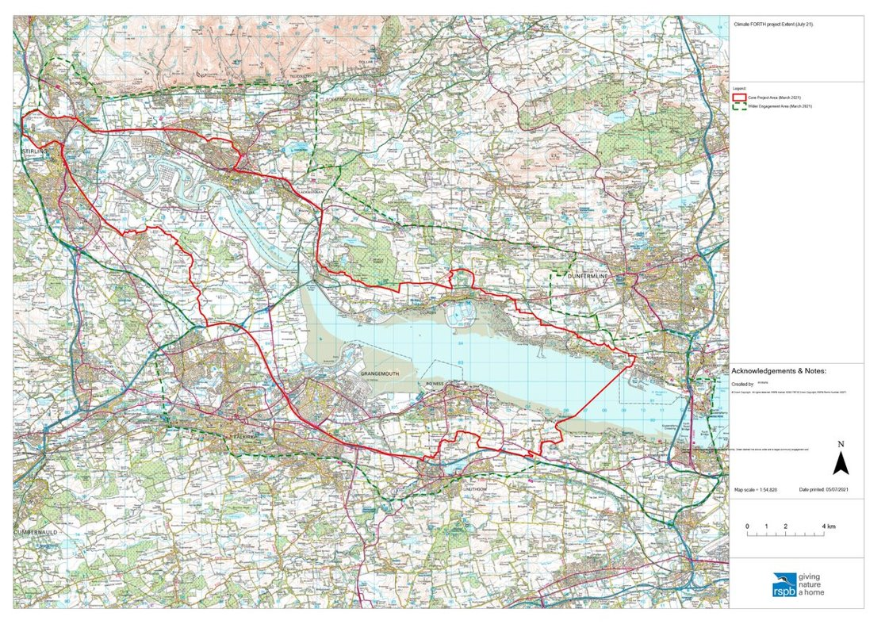
An explorable map of the Climate FORTH project area can also be seen at https://rspb.maps.arcgis.com/apps/webappviewer/index.html?id=1971361148964a3780ab5427a2fb8b07

Community Heritage Group Training and Mentoring Programme
The support being sought through this Invitation to Quote will further the objectives of Climate FORTH by empowering individuals and community/heritage-based groups around the Inner Forth to maintain, manage, and make the most of heritage assets (natural, built, and cultural).

This will be achieved through the development of a training and mentoring programme that will delivered by external providers through the delivery phase of Climate FORTH (2023 – 2026). The training and mentoring programme will provide groups and individuals the skills, confidence and capacity to ‘step up’ and take on new management of assets or be better placed to manage their existing asset portfolio. It is also hoped that the programme will help link up like-minded groups so they can share learning, resources and skills.
The natural, historic, and cultural heritage associated with this programme is likely to be at risk from at least one of the following issues:
- Damage, destruction or loss due to the impacts of climate change (e.g. sea level rise, surface water flooding, warmer, wetter temperatures)
- Lack of management or abandonment leading to neglect and failure to realize opportunities to contribute to the area’s resilience.
As such, increasing the skills base of those within the landscape who manage and identify long-term uses for heritage assets is of utmost value.

See https://www.innerforthlandscape.co.uk/about/climate-ready-forth for more information.

Scope of Services
1.Specification
Overview of work required
Climate FORTH is seeking the services of a consultant undertake the following:
- Identification of training and mentoring opportunities that fit with the priorities and interests of local groups and individuals and will enable them to increase their existing knowledge, skills and capacity to manage heritage assets. Some data and useful contacts relating to the priorities and interests of local groups and individuals will be provided by the Climate FORTH team.
- Develop a costed plan for a training and mentoring programme to increase community awareness and skills in identifying and addressing heritage maintenance issues. The Climate FORTH team and external providers will deliver this programme during the Climate FORTH delivery phase (2023-2026)
Methodology
The contractor will work chiefly with the Climate FORTH Project Officer for Community and Youth Development, as well as the wider Climate FORTH team, IFF Partnership, IFF Natural Heritage Working Group and IFF Historic Heritage Working Group – where necessary.
We anticipate this work is largely desk-based. However, the consultant may benefit from visiting and engaging with representatives of heritage themed community groups within the Climate FORTH project area to sense-check the training and mentoring proposals. Meetings can be held face to face or over Zoom/ Microsoft Teams, by agreement.
Deliverables
Throughout the commission, there will be a set of outputs required:
- Regular progress reports and update meetings with the Climate FORTH Project Officer for Community and Youth Development.
- A draft Scoping report outlining training and mentoring opportunities linked to the needs of the project’s stakeholders (i.e., communities, groups and individuals previously identified by the Climate FORTH project group).
- A final report containing a costed project plan for a training and mentoring programme, with identified providers, to be delivered during the delivery phase of Climate FORTH, 2023-2026.

Are you able to meet this specification in full? If so please give details below
If not please state any differences in service offered
Specification met? Yes /Part met / No (tick as appropriate)
Details

2.Duration of works:
The following timescale applies to the successful contractor.
Quotation process starts | Wednesday 25 May 2022
Deadline for quotations | 17:00 Monday 20 June 2022
Appointment of consultants | w/c 27 June 2022
Commencement of services – start up meeting to be held | w/c 4 July 2022
Draft Programme Plan | Thursday 4 August 2022
Final Programme Plan End of contract | Monday 29 August 2022

Are you able to meet this specification in full? If so please give details below
If not please state any differences in service offered
Specification met? Yes /Part met / No (tick as appropriate)
Details

3.Value of works & Contract management :
Up to £5,000 excluding VAT. Your fee should include for any other specialist deemed necessary to undertake this work. Fees shall be deemed to include all normally incurred expenses (including consumable materials, data licenses, permissions etc), disbursements and travel costs associated with the provision of the Services. The preferred payment schedule is 100% on completion.

Are you able to meet this specification in full? If so please give details below
If not please state any differences in service offered
Specification met? Yes /Part met / No (tick as appropriate)
Details

Award Criteria

Quotes should include the following:
- Proposed team – details and experience of the team involved, including identification of the project manager / team leader.
- Budget – a breakdown of costs to include:
  - Total cost for professional services excluding VAT
  - Total number of days required to undertake the work
  - Total number of days’ input and relevant day/hourly rate for each team member
  - Estimated costs allowed for travel and, separately, accommodation and other subsistence, if relevant
  - Estimated costs for any other expenses such as printing
  - Total cost for all work and expenses, excluding VAT
  - VAT status
- Methodology – confirmation of the proposed method and programme of work, taking into consideration the Scope of Services required
- Key sources – key sources and contacts to be used in undertaking the work
- Presentation – how findings and recommendations will be presented and proposed format of outputs.
- Insurance – details of relevant insurances and professional indemnities.

Quotes that fulfil essential requirements will be evaluated on the following basis:
Criterion | Weighting
Service Delivery | 35%
Price & Price Related | 20%
Relevant experience and technical knowledge | 35%
Timescale | 10%

Contract Management

The service commissioned will commence w/c 4 July, at the start up meeting and complete on 29 August 2022 with the submission of the final report.

The contractor will be expected to liaise with Connie Dawson, Climate FORTH Project Officer for Community and Youth Development throughout the duration of the works, with interim verbal/emailed progress reports to that Officer and an interim report at contract mid-point.

The contract will be managed by Connie Dawson, Climate FORTH Project Officer for Community and Youth Development. All correspondence and queries relating to the delivery of the contracted work or requests for further information should be directed to connie.dawson@rspb.org.uk

Company Information – please complete and provide with your quote
 | 1.0 | General
 | 1.1 | Registered Name  Trading Name (if different)
 | 1.2 | Correspondence Details  Name of person applying on behalf of the company  Address:  Telephone:  Mobile:  Email:
 |  | Registered office Address (if different from above)
 | 1.3 | Company Registration No (if applicable)  VAT registration number (if applicable)
 | 1.4 | Date company was founded (if a limited company, date of incorporation)
 | 1.5 | Company structure and nature of company  Please outline the nature of the company, whether it is a partnership, sole trader, plc etc.  Is the company proposed as party to the contract part of a larger organisation? If so please explain the relationship between the various parts of the organisation, up to the ultimate holding company.  Current number of full time equivalent staff currently employed by the company (not larger parent company)
 | 1.6 | Accreditation by / Membership of Trade Association(s)  Is your Company registered with any industry accreditation body? YES NO  If yes, please provide details:  Is your Company on any public sector Framework agreements? YES NO  If yes, please provide details:  Please state membership of any professional bodies/ other associations below:
 | 1.7 | Quality Assurance  Is all / part of your company ISO9001 Quality Assured? YES NO  Is all / part of your company ISO14001 Quality Assured? YES NO  If yes please provide copy of certification  Do you have any other Quality Assurance? If Yes, please summarise details below

 | 2.0 | Financial & Business Probity
2.1 |  | Judgements etc.  Are there any judgements, claims or suits pending or outstanding against your company?  Yes No If Yes, please provide full details  Has your company ever failed to complete a contract?  Yes No If Yes, please provide full details
2.2 |  | Please answer all of the following questions as they apply to your Company’s circumstances. Please confirm that:  1) being a company, no resolution has been passed or Order of the Court made for the company’s winding up otherwise than for the purposes of bona fide reconstruction or amalgamation, nor has a receiver, manager or administrator on behalf of a creditor been appointed in respect of the company’s business or any part thereof, nor is it the subject of any proceedings for any of the above procedures, nor is it the subject of similar procedures under the law of any other state.  Confirmed Not confirmed Non-applicable  2) being a partnership, it has not granted a trust deed or become otherwise apparently insolvent, or it is not the subject of a petition presented for sequestration of its estate.  Confirmed Not confirmed Non-applicable  3) being an individual, you are not bankrupt, or have not had a receiving order or administration order made against you, or have not made a composition or arrangement or trust deed with or for the benefit of your creditors, or have not made any conveyance or assignment for the benefit of your creditors, or have not had a petition presented for sequestration of your estate or do not appear to be able to pay or to have no reasonable prospect of being able to pay a debt within the meaning of the Insolvency Act or any similar procedure under the law of any EC member state.  Confirmed Not confirmed Non-applicable  4) no Directors, Partners, Associates or the Company Secretary have been involved in any Company which has been liquidated or gone into receivership.  Confirmed Not confirmed Non-applicable  5) none of the Directors, Partners, Associates or the Company Secretary have been convicted of a criminal offence relating to the conduct of their business or profession.  Confirmed Not confirmed Non-applicable  6) neither the Company nor any of the Directors, Partners, Associates or Company Secretary has committed an act of grave misconduct in the course of their business or profession.  Confirmed Not confirmed Non-applicable  7) all obligations relating to the payment of taxes under the law of any part of the United Kingdom or the EC member state in which the Company is established has been fulfilled  Confirmed Not confirmed Non-applicable  8) all obligations relating to the payment of social security contributions under the law of any part of the United Kingdom or the EC member state in which the Company is established have been fulfilled.  Confirmed Not confirmed Non-applicable  If you have ticked ‘Not confirmed’ for any questions above please give details here

2.3 | Please list the names of any Director, Partner, Associate or Company Secretary who have been employed by the RSPB, giving department and dates.  Please give details of any Director, Partner, Associate or Company Secretary who have a relative who is employed by the RSPB at a senior level.  Please list the names of any Director, Partner, Associate or Company Secretary who have any involvement in other Companies who provide services to the RSPB  Is any work being undertaken or likely to be undertaken during the next three years by the Company or staff within it which could give rise to a conflict of interest through acting for third parties or otherwise? If yes, please explain the actual or likely circumstances and how such potential conflicts of interest would be handled.

2.4 | Insurances (please supply a scanned copy of each certificate)
 |  | Insurer | Policy No | Value of Cover | Expiry Date
 | Employers Liability
 | Public Liability
 | Prof. Indemnity
All Risks
(if applicable)

2.5 | Has your company (or any building/project you have undertaken) won any awards, accolades or recognition?  YES NO If yes please provide full details.

3.0 | Health & Safety and Environment
3.1 | Has your company been served with any enforcement or prohibition notices or been prosecuted in the past 5 years for breaches of health & safety legislation?  YES NO If yes please provide full details.
3.2 | Has your company been served with any enforcement or prohibition notices or been prosecuted in the past 5 years for breaches of environmental legislation?  YES NO If yes please provide full details.
3.3 | Has your company been served with any enforcement or prohibition notices or been prosecuted in the past 5 years for breaches of data protection legislation?  YES NO If yes please provide full details.
3.4 | Have any restrictive clauses in relation to your company’s Employer’s Liability, Public Liability or Professional Indemnity Insurance policies been enforced in the last 5 years due to past Health & Safety performance?  YES NO If yes please provide full details.

Quote please complete

Cost
Cost for providing goods/services, as outlined in Scope of Services | £ + VAT

Added Value
As well as any charity rate that you may be able to offer, the RSPB is always open to corporate partnerships that deliver benefit to your organisation, the RSPB and nature. Working as part of your CSR agenda we can provide opportunities for fundraising, secondments, interns and volunteering, offering your staff both personal and career development opportunities. We also welcome all forms of gifts in kind as valuable contributions to our work to Give Nature a Home.

Suppliers should provide details of any associated added value features/services/gifts in kind available to the RSPB under the terms of this Quote. (Attach separate document if needed).

Please note, added value donations will not be part of the criteria we use to decide on which supplier to choose.

References
Suppliers are requested to provide details of three references from their existing clientele, supplying full name, address, telephone number, email address, contact name, period of Contract and the estimated annual value of the Contract. In supplying this information, Suppliers shall have granted the RSPB permission to seek such information as deemed necessary, in relation to the Suppliers performance with their nominated references.
Reference 1
Company Name
Address
Telephone No |  | Ext
Email
Contact |  | Dates of work
Nature of work done |  | Value of contract

Reference 2
Company Name
Address
Telephone No |  | Ext
Email
Contact |  | Dates of work
Nature of work done |  | Value of contract

Reference 3
Company Name
Address
Telephone No |  | Ext
Email
Contact |  | Dates of Work
Nature of work done |  | Value of contract

Terms and Conditions
The basis of the contractual agreement between RSPB and the applicant is detailed in the RSPB Terms and Conditions – please click on this link to download. In applying for this work you are explicitly agreeing to be bound by these Terms and Conditions for the duration of the contract. If you require any alterations to these Terms and Conditions please state your issues below. (Attach separate document if needed)

The RSPB expects that all suppliers it works with to adhere to certain ethical and environmental standards. Please download the RSPB Ethical and Environmental Procurement Policy and tick this box if you agree to be bound by its terms and conditions

Signed
On behalf of
Date

Please note: a name added in an electronic document is functionally equivalent to a signature.

