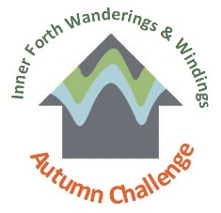
Wanderings & Windings
Autumn Challenge
Name:
I pledge to complete the Inner Forth Wanderings & Windings Autumn Challenge by walking/cycling/wheeling ………… miles by 31st October 2020.
We would LOVE to see your adventures so please share your experiences on social media, tagging us and using the hashtags #YCW2020 and #W&WAutumnChallenge. Good Luck!
Once you have accomplished your challenge, please email your completed log-sheet, along with any screenshots or photo’s you have taken to info@innerforthlandscape.co.uk.

 | Route Number | Distance Completed | Distance Remaining | Evidence e.g. picture, your word, fitness app
Oct 1
Oct 2
Oct 3
Oct 4
Oct 5
Oct 6
Oct 7
Oct 8
Oct 9
Oct 10
Oct 11
Oct 12
Oct 13
Oct 14
Oct 15
Oct 16
Oct 17
Oct 18
Oct 19
Oct 20
Oct 21
Oct 22
Oct 23
Oct 24
Oct 25
Oct 26
Oct 27
Oct 28
Oct 29
Oct 30
Oct 31

