***

Date: 1st August 2023

Dear Sir or Madam,

**Request for Quotation:** **Provision of video production and photography for the Round the Forth Cycle Route and Inner Forth area**

You are invited to quote in competition with others to provide services as specified below:

RSPB Scotland, on behalf of the Inner Forth Futures partnership (IFF), wishes to commission an organisation or individual who can deliver bespoke videos and photographs to promote the Round the Forth cycle route, linked cycle day trips, and the Inner Forth area.

The provision of bespoke video production and photography for the Round the Forth Cycle Route sits within the Climate FORTH (Furthering Our Resilience Through Heritage) project as part of a wider suite of activities aiming at developing and promoting cycle tourism in the Inner Forth area and supporting the local economy. Climate FORTH will be delivered over three years from August 2023, subject to a successful delivery stage application to the National Lottery Heritage Fund.

The content created will be used to showcase the Round the Forth Route and associated day trips on the VisitScotland Sustrans journey planner website: [Sustrans map of cycle routes in Scotland - Sustrans (visitscotland.com)](https://www.visitscotland.com/see-do/active/cycling/sustrans-cycle-map/), as well as to provide video and photo content that local businesses can use copyright-free to promote their businesses and the area. IFF will retain all copyright of the footage and photographs for future use. See section “Scope of Services” below for a detailed brief of the services required.

The value of the work will be up to £7,800 excluding VAT. Work will occur from early September to the end of October 2023, subject to final confirmation of grant funding.

The successful candidate should demonstrate previous experience in similar work.

All filming and photography must be completed by 31st October 2023.

Your quote should be emailed to [helene.corrieu@rspb.org.uk](mailto:helene.corrieu@rspb.org.uk) by 5pm on 1st September 2023. Appointment is subject to final confirmation of grant funding.

If you wish to discuss any aspect of this quote prior to submitting, please email [helene.corrieu@rspb.org.uk](mailto:helene.corrieu@rspb.org.uk), or call 07516588143.

Yours faithfully

Helene Corrieu

Climate FORTH Project Officer – Visitor & Business Engagement

Inner Forth Futures

RSPB

**A Brief Introduction**

For details on the RSPB’s challenges and achievements in the previous financial year please go to

<https://ww2.rspb.org.uk/about-the-rspb/about-us/how-we-are-run/annualreview/>

For details on the RSPB Mission please go to

<https://ww2.rspb.org.uk/about-the-rspb/about-us/our-mission/>

**Inner Forth Futures**

**Who we are**

Inner Forth Futures (IFF) is an initiative comprising 8 member organisations including RSPB Scotland (lead agency), NatureScot, Clackmannanshire Council, Stirling Council, Falkirk Council, Fife Council, Green Action Trust, and Sustrans. Historic Environment Scotland are an advisory member to the initiative. As a grouping of local authorities, public bodies, charities and community groups, we are inclusive, cooperative and listening, but also decisive, and able to make things happen.

**Where we work**

The IFF project area (as shown in the map overleaf) includes the parts of Stirling, Falkirk, Clackmannanshire and Fife that surround the Inner Forth. This landscape defies the rules. Spectacular flocks of waders and wildfowl feed against a backdrop of steel towers and chimneys. Ancient castles gaze down on factories and warehouses, while the relics of past industries are now surrounded by woodlands and wildflowers. At the heart is the tidal River Forth and the dramatic mudflats and saltmarshes along its shores.

Sadly, many people only see the industry and commerce, while the area’s rich natural, cultural and historic heritage is often overlooked or neglected. We aim to create a greater appreciation and awareness of this rich heritage.

**Our vision and objectives**

Our vision is that the sense of connection, purpose and place that put the Inner Forth at the forefront of the industrial development of Scotland will be revitalised. We aim to achieve this using a landscape-scale approach with heritage at its core to engage people in new ways in its future management.

**Climate FORTH: Furthering Our Resilience Through Heritage**

The Climate FORTH project has been developed over the past year to contribute significantly to delivering our vision and will be delivered between August 2023 and July 2026, subject to a successful delivery stage application to National Lottery Heritage Fund. Climate FORTH will make the following differences for local heritage, people and place by working in targeted locations within the Inner Forth’s four local authority areas and 215 km2 landscape and disseminating our findings to inspire further action:

1. The Inner Forth's heritage is valued and has inspired action to meet Scotland's net zero climate targets and made positive economic and societal change.
2. The Inner Forth's natural and built heritage assets have an increased resilience to societal and climatic change.
3. People and places within the Inner Forth have an increased resilience to change, as a result of heritage supporting the economy, healthy lifestyles, sustainable choices and a just transition.

Climate FORTH will support a move to a greener future and post-pandemic recovery and generate opportunities to share learning, influence adaption and inspire the change needed to transition to a climate resilient landscape in the Inner Forth and beyond. This will be achieved using locally-created, measurable resilience plans with participatory budgets for delivery, targeted action to demonstrate ways to increase resilience of heritage assets, tools and events to promote the principles of 20-minute neighbourhoods, skills development and capacity building, and initiatives to promote local, sustainable tourism. A new Youth Panel will engage a different demographic in decisions about their local places and Climate FORTH’s activities, including through a dedicated micro-grant scheme. See [www.innerforthlandscape.co.uk](http://www.innerforthlandscape.co.uk/) for more information.

**Map of the Climate FORTH project area:**

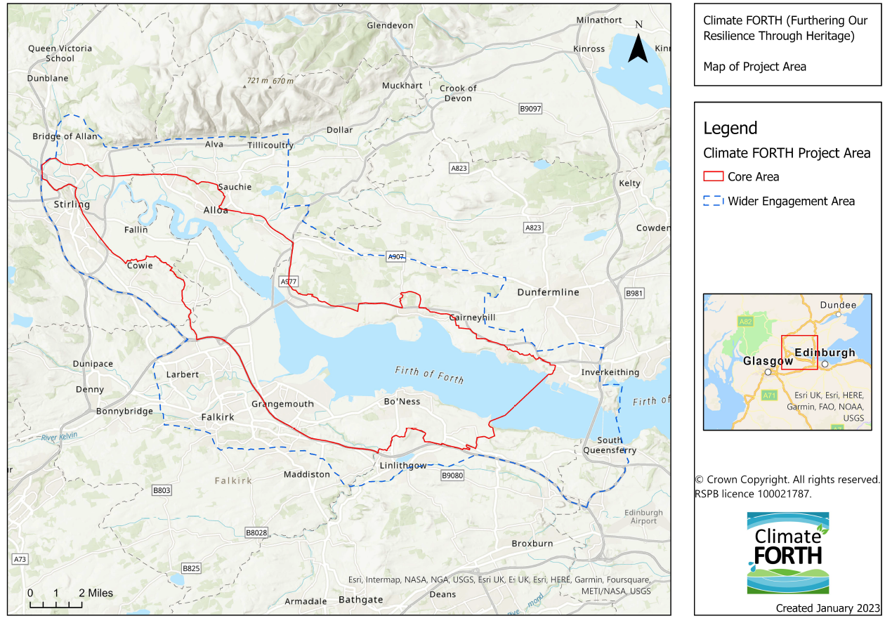

An explorable map of the Climate FORTH project area can also be seen at <https://rspb.maps.arcgis.com/apps/webappviewer/index.html?id=1971361148964a3780ab5427a2fb8b07>

**What we want to achieve**

With the aim to revitalise the Round the Forth cycle route (NCN76) and promote cycle tourism in the Inner Forth area, The Climate FORTH project will rebrand the Round the Forth cycle route as a circular 2-day cycle route around the upper firth of Forth (between the Forth Bridges and Stirling – see map below).

The 2-day cycle route will then be added, along with a selection of associated day trips, onto the VisitScotland Sustrans cycle journey planner website: [Sustrans map of cycle routes in Scotland - Sustrans (visitscotland.com).](https://www.visitscotland.com/see-do/active/cycling/sustrans-cycle-map/#/) The microsite already showcases a selection of key NCN routes and linked day trips, such as The Lochs and Glens Way, Caledonian Way, John Muir Way, Loch Ness 360 and Union & Forth Clyde Canal towpaths.

The filming and photography content provided through this contract will be part of the content added to the VisitScotland Sustrans website, complementing the cycle route descriptions and information (which will be developed as part of a separate contract).

**Map of the Round the Forth cycle route:**

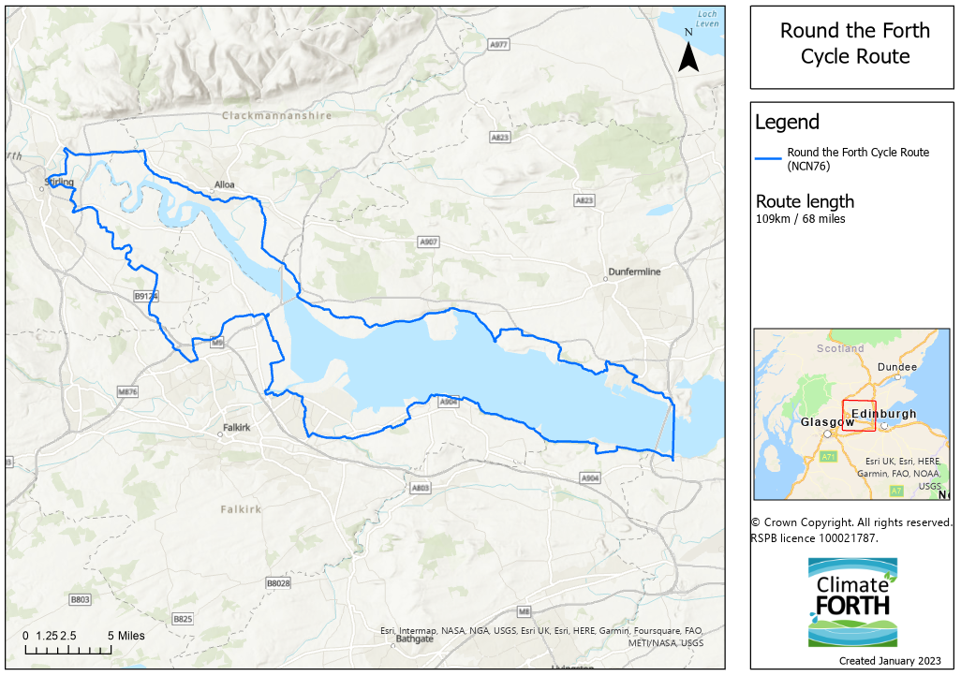

**Specifications**

**Aim**

Round the Forth Cycle Route (videos and photographs)

To showcase the Round the Forth 2-day circular cycle route (see map above) and its tourism offer.

Cycle day trips (videos and photographs)

To showcase a selection of cycle day trips which are located near the Round the Forth cycle route, and reflect the experience that cyclists can have on these routes.

Tourism toolkit content (photographs)

To create a bank of images showcasing the natural and cultural heritage tourism offer of the Inner Forth area. This content, along with the photographs and videos of the Round the Forth route and associated day trips, will be integrated into our “Tourism Toolkit” and will be available copyright-free for businesses to use to promote their business and the local area.

**Outputs**

Videos (9 total):

* 1x 2 min short film, no narration (music and caption), showcasing the Round the Forth Cycle Route
* 4x short 30 second edits with music and caption only, showcasing highlights of the Round the Forth Route for sharing on social media
* 4x short films (1 minute each) showcasing a selection of day trips (4 day trips)
* Videos to include some aerial drone imagery as well as café stops/attraction experiences
* The videos need to cover the list (to be provided) of landmarks, attractions, scenery and businesses to promote.

Photographs (140 – 160):

* Minimum 60 photographs, showcasing cyclists and highlights of the Round the Forth Route
* Minimum 60 photographs, showcasing cyclists and highlights of the day trips (between 4 and 8 day trips)
* Between 20 and 40 photographs showcasing natural and built heritage attractions in the Inner Forth area. List of sites to be provided and confirmed at start-up meeting.

**Scope of services**

* Travel to the area to undertake filming and photographs.
* A list of sites to be included in the footage will be provided by IFF, as these are still being identified.
* Details of the selected day trips will be provided to the successful photo/videographer in September 2023, as these are still being identified. This will include between 4 and 8 day trips. Photographs should showcase highlights of each of the day trips (between 4 and 8). Short films will showcase 4 of the day trips.
* Filming and photography days – please include the number of days required in your quote.
* You will be required to film, edit and produce each clip.
* Video clips to be supplied as MP4 video files
* Photographs to be converted from RAW to JPG format
* All videos and photographs should be of professional quality to be used online and promotional material.
* IFF will provide any required branding for the videos.
* You must allow the client the chance to view and provide feedback (2 stages of feedback) before finalising the edit of each clip.
* IFF will retain all copyright of the footage and photographs for future use
* A copy of original footage must be provided in addition to edited footage, for further use
* All videos must include location titles
* You will be required to source models. Model release forms must be completed for all participants and should be made available to IFF when the filming is completed.
* Video clips must include music. Documentation and releases to be supplied for any music used in the videos.

This contract will involve working closely with the Climate FORTH team and Sustrans Network Engagement Officer (Business and Tourism), providing regular updates via progress meetings.

Consideration:

Due to the tight timescale involved, the successful photo/videographer will be asked to prioritise the Round the Forth footage early September, as the selection of cycle day trips will still be ongoing at the start of the contract. Detail of the day trips and suggested locations for day trip footage will be provided during September 2023.

Content:

The videos and photographs will include inspirational footage of the Round the Forth way and showcase the cycle routes and local heritage. This will include natural, built and cultural heritage. The content will also include key stops, attraction experiences and local service providers.

A list of sites to be included in the footage will be provided by IFF.

We will work with you at inception meeting to decide on content and agree on a storyboard.

**How the content will be used:**

Videos and photographs related to the Round the Forth cycle route and associated day trips will be added to the VisitScotland Sustrans website [Sustrans map of cycle routes in Scotland - Sustrans (visitscotland.com)](https://www.visitscotland.com/see-do/active/cycling/sustrans-cycle-map/#/day-trips/loch-katrine-loop), to complement and illustrate the route information.

The videos and photographs will be used on Inner Forth Futures, Sustrans and VisitScotland’s websites, social media accounts, as well as printed material as part of the route’s launch and ongoing promotion.

A selection of videos and photographs will be integrated into the Climate FORTH Tourism Toolkit and made available free of charge to local businesses, tourism associations and destination marketing organisations for their own use as part of their business promotion and destination promotion.

**Tone and Style**

The Round the Forth cycle route is aimed at cyclists, including less confident cyclists who may have never undertaken any multi-day cycle touring before. The day trips are targeted at less confident cyclists, families, day and multiday visitors. Due to the make up of the route, it is mostly suitable to touring bikes. Some sections are also suitable to road bikes and others to mountain bikes.

It is important that the video and photographs accurately reflects the provisions and make of the route, whilst also highlighting the Inner Forth’s Unique Selling Point: The Inner Forth is an area rich in natural and cultural heritage, including the wildlife and landscape surrounding the Forth Estuary, and the region’s strong industrial past. More information about the Inner Forth’s natural and cultural heritage can be provided by IFF.

As the work is expected to take place in September and October, weather should be taken into account and, when possible, used to create the appropriate atmosphere.

Examples of similar photo and video work done for other routes can be accessed on the VisitScotland and Sustrans website (e.g.: [Far North Way video](https://www.visitscotland.com/see-do/active/cycling/sustrans-cycle-map/#/the-far-north-way), [Far North Way photos](https://www.visitscotland.com/see-do/active/cycling/sustrans-cycle-map/#/the-far-north-way/the-far-north-way-explorer/)).

*Are you able to meet this specification in full? If so please give details below*

*If not please state any differences in service offered*

|  |
| --- |
| Specification met? Yes /Part met  / No (tick as appropriate)  Details |

**Timescales**

The following timescale applies to the successful contractor.

|  |  |
| --- | --- |
| Quotation process starts | 1st August 2023 |
| Deadline for quotations | By 1st September 2023, 5pm |
| Appointment of contractor | w/c 4th September 2023 |
| Commencement of services – start up meeting to be held.  IFF to provide location details for Round the Forth route footage and Inner Forth destination photography. | As soon as possible after appointment |
| Round the Forth route filming and photography | From early September 2023 |
| Inner Forth destination photography | From early September 2023 |
| IFF to provide location details for day trips filming and photography | By mid-September 2023 |
| Day trips filming and photography | From mid-September 2023 |
| IFF to provide new Round the Forth branding to add to the video files | w/c 23rd October 2023 |
| Submission of film and photography files | By 31st October 2023 |
| End of contract | 31st October 2023 |

*Are you able to meet this specification in full? If so please give details below*

*If not please state any differences in service offered*

|  |
| --- |
| Specification met? Yes /Part met  / No (tick as appropriate)  Details |

**Value of works**

Up to £7,800 excluding VAT. Your fee should include for any other specialist deemed necessary to undertake this work. Fees shall be deemed to include all normally incurred expenses (including consumable materials, data licenses, permissions, etc.), disbursements and travel costs associated with the provision of the Services. The preferred payment schedule is 100% on completion.

*Are you able to meet this specification in full? If so please give details below*

*If not please state any differences in service offered*

|  |
| --- |
| Specification met? Yes /Part met  / No (tick as appropriate)  Details |

**Award Criteria**

Quotes should include the following:

1. Proposed team – details and experience of the team involved, including identification of the project manager / team leader.
2. Budget – a breakdown of costs to include:
3. Total cost of all work and expenses, excluding VAT
4. Number of filming and photography days / camera time
5. Video and photo editing time
6. Music
7. Estimated costs allowed for travel and, separately, accommodation and other subsistence, if relevant
8. VAT status

3. Insurance – details of relevant insurances and professional indemnities.

Quotes will be evaluated on the following basis:

|  |  |
| --- | --- |
| **Criterion** | **Weighting** |
| Service Delivery | 35% |
| Price & price related | 20% |
| Relevant experience and technical knowledge | 35% |
| Timescale | 10% |

**Contract Management**

The service commissioned will commence early September 2023 at the start-up meeting and complete on 31st October 2023 with the submission of the film and photography files.

The contractor will be expected to liaise with the Climate FORTH team throughout the duration of the works. The contract will be managed by the Climate FORTH Project Officer - Communications.

Until contract start up, correspondence and queries relating to the delivery of the contracted work or requests for further information should be directed to Helene Corrieu, Climate FORTH Project Officer – Visitor & Business Engagement, [helene.corrieu@rspb.org.uk](mailto:helene.corrieu@rspb.org.uk).

|  |  |
| --- | --- |
|  | Name of Company    Are you self employed? Yes  No  (Please tick as appropriate) |
|  | Address:    Telephone:    Mobile:    Fax:    Email: |
|  | VAT registration number (if applicable)    Name of person applying on behalf of the company |

*Are you able to meet the specification in full? If so please give details below*

*If not please state any differences in goods / service offered*

|  |
| --- |
| Specification met? Yes /No (tick as appropriate)  Details |

**Cost**

|  |  |
| --- | --- |
| Cost for providing goods/services, as outlined in specifications | £      + VAT |
| Cost for extra work for special events etc (if applicable) | £      /hour + VAT |

**Added Value**

As well as any charity rate that you may be able to offer, the RSPB is always open to corporate partnerships that deliver benefit to your organisation, the RSPB and nature. Working as part of your CSR agenda we can provide opportunities for fundraising, secondments, interns and volunteering, offering your staff both personal and career development opportunities. We also welcome all forms of gifts in kind as valuable contributions to our work.

Suppliers should provide details of any associated added value features/services/gifts in kind available to the RSPB under the terms of this Quote. (Attach separate document if needed).

Please note, added value donations will not be part of the criteria we use to decide on which supplier to choose.

**Terms and Conditions**

The basis of the contractual agreement between RSPB and the applicant is detailed in the [RSPB Terms and Conditions](https://www.rspb.org.uk/about-the-rspb/about-us/how-the-rspb-is-run/supplier-terms-and-conditions/) – please click on this link to download. In applying for this work you are explicitly agreeing to be bound by these Terms and Conditions for the duration of the contract. If you require any alterations to these Terms and Conditions please state your issues below. (Attach separate document if needed)

The RSPB expects that all suppliers it works with to adhere to certain ethical and environmental standards. Please download the [RSPB Ethical and Environmental Procurement Policy](https://www.rspb.org.uk/about-the-rspb/about-us/how-the-rspb-is-run/supplier-terms-and-conditions/) and tick this box if you agree to be bound by its terms and conditions 

|  |  |
| --- | --- |
| Signed |  |
| On behalf of |  |
| Date |  |

**Please note: a name added in an electronic document is functionally equivalent to a signature.**